PoFormer: A Transformer-CNN hybrid model for Segmentizing Pavement Pothole

Tianjie Zhang1, Zhen Liu2, Xingyu Gu2 and Yang Lu3*

1 Department of Computer Science, Boise State University, Boise, ID, 83725

2 School of Transportation, Southeast University, Nanjing, Jiangsu Province

3 Department of Civil Engineering, Boise State University, Boise, ID, 83725

***Abstract*:**

This work introduces PoFormer, a novel Transformer-CNN hybrid model designed for the precise segmentation of pavement potholes. As a significant issue in road maintenance, the accurate detection and segmentation of potholes are critical for road safety and transportation infrastructure management. Traditional image processing techniques fall short due to the complex variations in pothole appearances and environmental conditions. PoFormer addresses these challenges by integrating the expansive representational capacity of Transformers with the precise local feature delineation capabilities of Convolutional Neural Networks (CNNs). We compiled a varied pothole dataset and conducted comprehensive experiments, evidencing that PoFormer surpasses current deep learning models including U-Net, E-Net, LRASPP, FCN and AttuNet with a mean Intersection over Union (mIoU) of 77.23% and mean Pixel Accuracy (mPA) of 84.48%. Our approach shows promise in enhancing automated road condition assessment and maintenance planning.

***Key words:***  **Transformer, pothole, image segmentation, CNN, Deep learning**

# 1. Introduction

Due to the climate changes such as heavy snow and rainstorms, there are increasing pavement defects like potholes all over the world [1]. Potholes not only pose safety hazards to road users but also contribute to accelerated pavement deterioration [2]. Accurately identifying and segmenting potholes from pavement images is crucial for effective road maintenance planning, targeted repairs, and resource allocation. Pothole detection and maintenance are becoming of paramount importance in transportation infrastructure management. Traditionally, the pothole is manually inspected by professional engineers, but it is dangerous, labor-intensive, inefficient, and time-consuming [3]. Furthermore, the manual pothole detection is subjective and very dependent on the experience and knowledge of the engineers [4]. Therefore, image processing techniques are emerged to solve this problem. For example, Buza et al. [5] presented an unsupervised vision-based method by using image processing and spectral clustering to identify and estimate the location of potholes. This method was tested on 50 images and got an accuracy of 81%. Gao et al. proposed a method by integrating grayscale and texture features to rapidly and accurately detect potholes. This method was evaluated on a customed collected dataset and got a F1 score of 98.7%. Koch et al. [6] proposed a novel method based on a shape extraction method. However, methods based on image processing techniques often struggle to handle the complex variations in pothole shape, texture, and lighting conditions.

In recent years, deep learning models have emerged as a superior alternative, offering significant advantages over traditional image processing approaches. Deep learning, powered by artificial neural networks with multiple layers, has revolutionized various fields, including transportation infrastructure detection. The ability of deep learning models to automatically learn and extract meaningful features from data enables them to surpass the limitations of handcrafted features used in traditional methods. Deep learning approaches, such as convolutional neural networks (CNNs), have demonstrated superior performance in a wide range of computer vision tasks, including object detection, defect classification, and semantic segmentation. For example, Zhang et al. [7] proposed an ECSNet in segmenting the pavement distress in a real-time task. Ukawah et al. [8] used YOLOv3 SPP to detect the asphalt pavement pothole in a self-collected dataset and the result showed a mAP of 88.93%. Ahmed et al. [9] proposed a modified VGG-16 by removing some convolutional layers and changing different dilation rates as a backbone in a Faster RNN network. The results showed that the modified VGG-16 can get a higher presision of 81.4% than VGG-16. The YOLOV5 with ResNet as its backbone got the highest mAP of 64.12%. These deep learning models leverage the hierarchical nature of neural networks to capture both low-level local features and high-level contextual information, enabling them to discern subtle patterns and distinguish between different types of distresses.

While deep learning models have yielded impressive results, recent advancements in the field of natural language processing have introduced a new paradigm: Transformers [10]. Transformers have revolutionized language modeling tasks by effectively capturing long-range dependencies and global context. This attention-based architecture has shown remarkable success in handling sequential data and has recently been extended to image analysis tasks. For example, Dosovitskiy et al. [11] proposed a Vision Transformer model (ViT) on image classification tasks and it was compared to state-of-the-art convolutional networks including ResNet and EfficientNet. The results showed that the proposed ViT performed better on datasets like ImageNet, CIFAR and Oxford-IIIT Pets. Zheng et al. [12] proposed a sequence-to-sequence structure, SEgementation TRansformer (SETR), to treat the image segmentation tasks. The transformer layer was used to encode the images through a sequence of patches. This method reached a mean Intersection over Union (mIoU) of 82.15% in the Cityscape validation dataset. These attempts showed that transformer layers are good at encoding the information from the images. Transformers have also started been utilized and applied in the pavement crack detection. Guo et al. [13] presented a Crack Transformer by integrating a swim transformer as its encoder and a Multi-Layer Perception (MLP) as its decoder to detect and segment the pavement cracks. Three crack datasets including CFD, Crack500 and CrackSC were tested and it showed the Crack Transformer can better retrieve the crack length. Han et al. [14] proposed Transformer FRTS to predict various asphalt pavement health indicators like rutting depth and surface texture depth. The inherent ability of transformer to model and extract complex relationships and capture fine-grained details makes them well-suited for analyzing spatial patterns in pavement images. However, transformer as decoders can be dependent on the specific application and the architecture of the network. In some cases, they might not be as effective as other approaches, such as CNNs, particularly when it comes to local feature extraction and pixel-level prediction tasks [15].

Therefore, in this paper, we present a novel approach, PoFormer, which is a Transformer-CNN hybrid model to leverage the power of transformers and CNNs. In this model, the input images would be sequenced first to several patches and then a transformer-based encoder would be adopted to extract the pattern and information from the patches. And then, a decoder with 4 convolutional layers is utilized to take the encoded information and spatial features and reconstruct them into an output of the same size as the original image, but with segmented regions. By adapting CNN-transformer-based architectures specifically for pothole detection, we aim to overcome the limitations of traditional CNN-only methods and further improve the accuracy and robustness of pothole segmentation. Through extensive experimentation and comparisons with traditional deep learning models, we demonstrate the effectiveness of our proposed approach in accurately identifying and delineating potholes from pavement images.

In the following sections, we outline the methodology used for pothole segmentation, present the experimental results, discuss the implications of our findings, and conclude with remarks on the potential and future directions of transformer-based approaches for pavement analysis.

# 2. Methodology

## 2.1. PoFormer

A Transformer-CNN hybrid model, PoFormer, is proposed in this work to segment the pothole from the pavement. The architecture of the proposed PoFormer is shown in Figure 1.

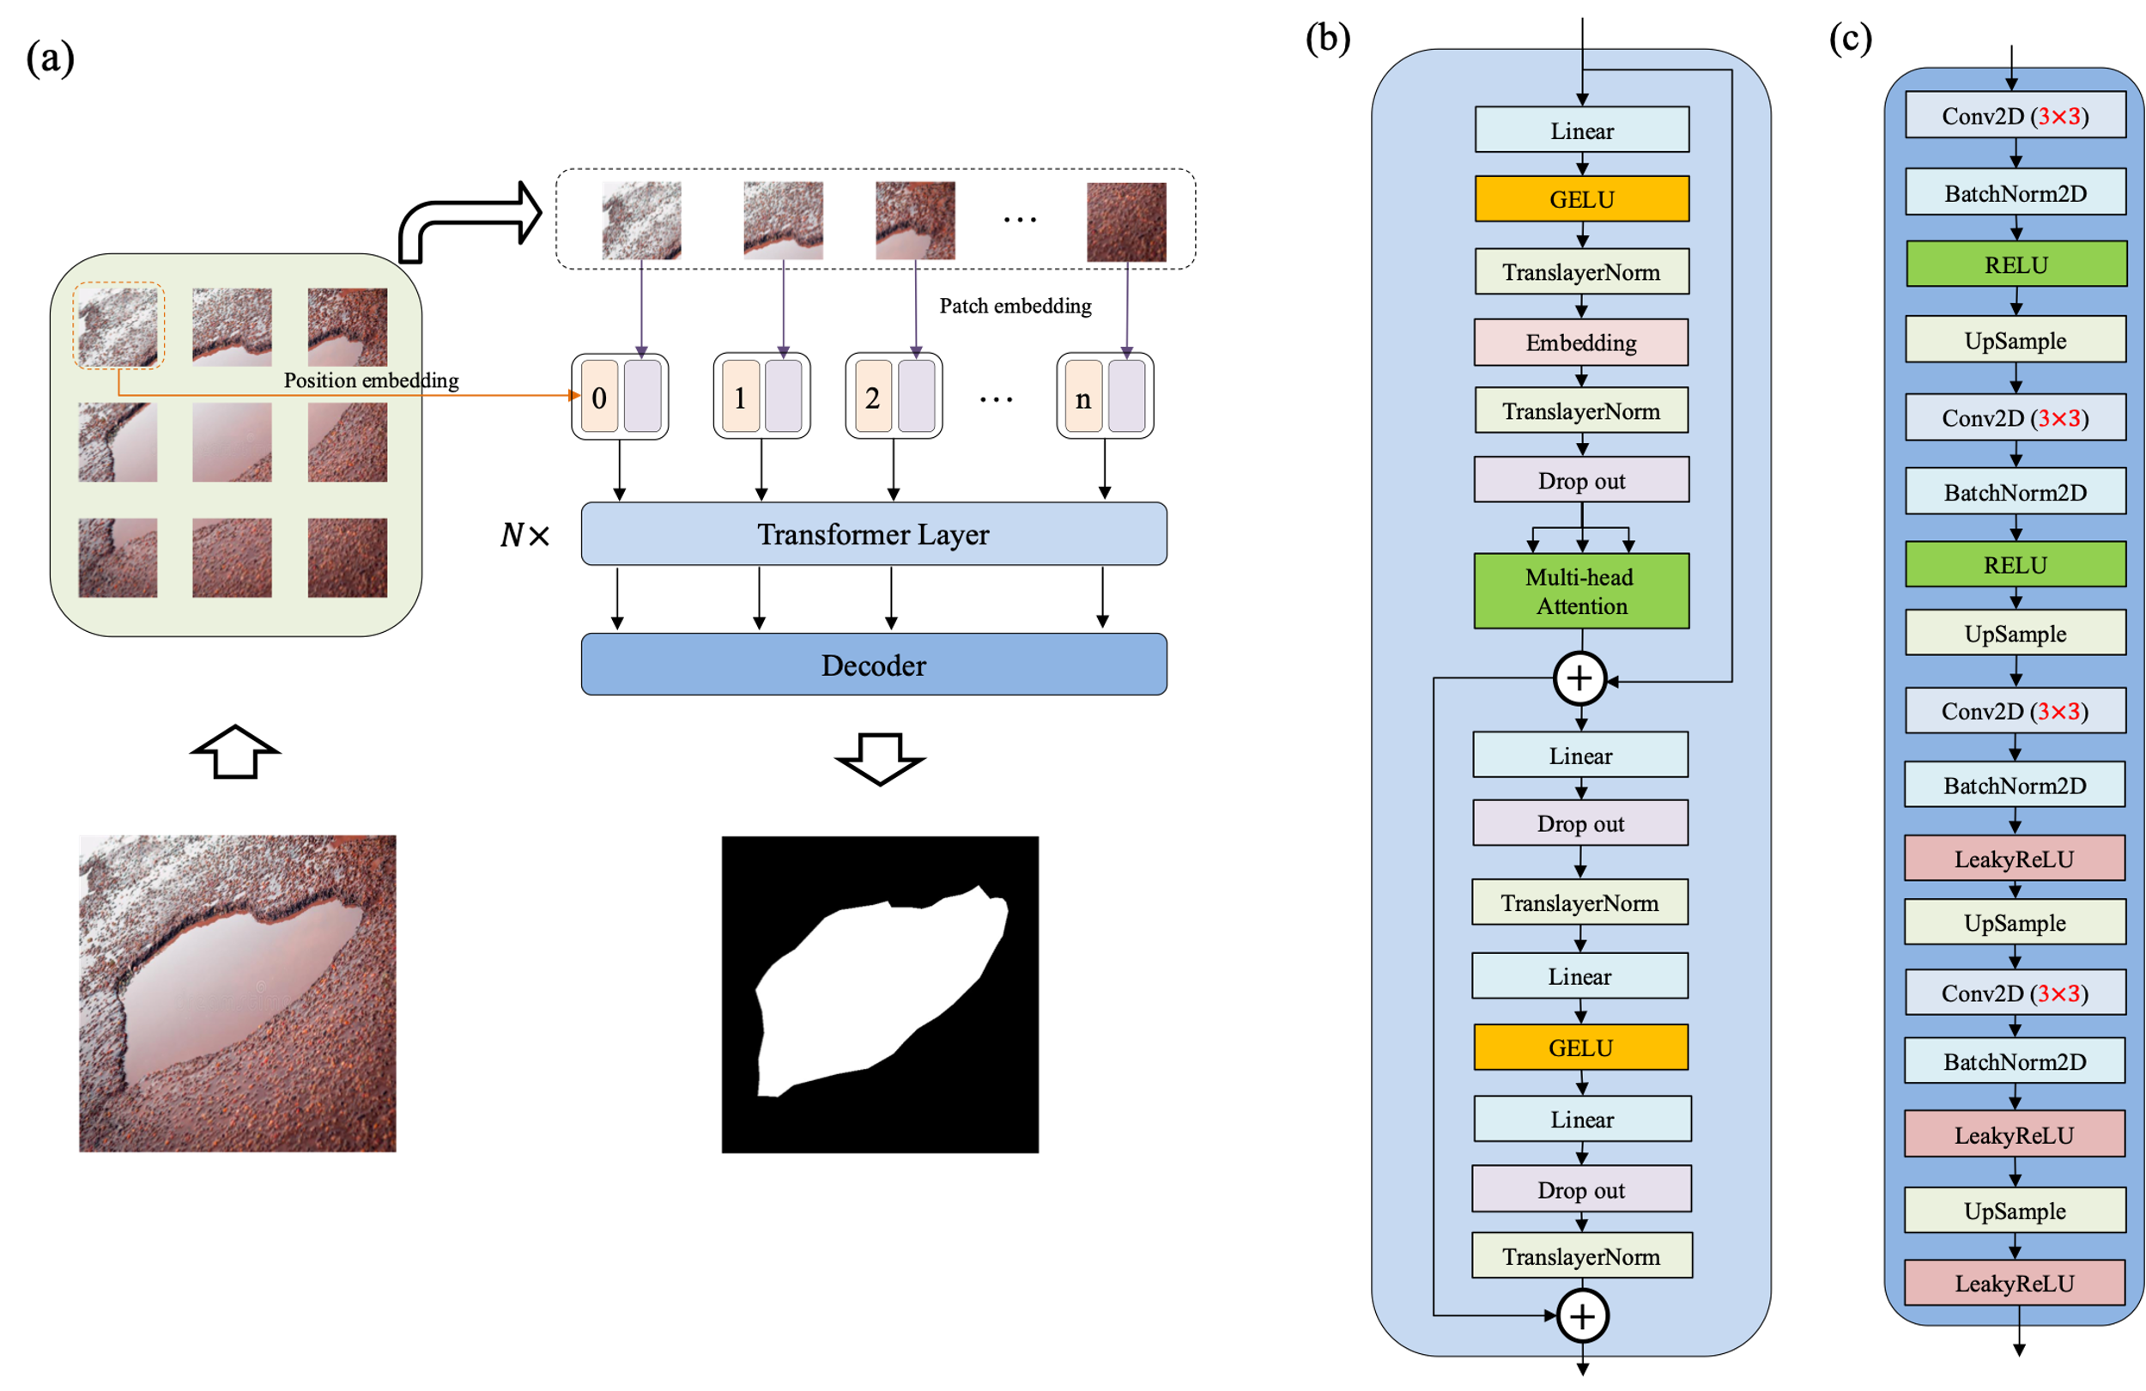

**Figure 1.** The architecture of the proposed PoFormer and its components. (a) The overall architecture of the PoFormer model. (b) The Transformer Layer and it is utilized as the encoder in this model to extract the information from the images; (c) The structure of the Decoder, which is a CNN-based structure.

As illustrated in Figure 1, the proposed PoFormer architecture is consisting of an image sequentialization part, an encoder and a decoder. The resolution of images is different because the images are collected from different devices and sources. Therefore, the input images would be resized to $256×256$ first before doing the image sequentialization as the model requires a fixed-size input which is crucial for batch processing. Moreover, resizing to $256×256$ helps to reduce the computational burden, making the training and inference processes more efficient. In this process, the 2D images would be transferred to one-dimensional sequences first to meet the requirement of the input to a transformer layer. The model intakes a pavement image and partitions it into *n* patches (in this case, each patch has a resolution of $32×32$, therefore, n equals to 64). These patches undergo a linear transformation to obtain flat embeddings (*E*) with an added positional encoding (*P)*, formalized as *E*(*pi*)+*P*(*i*), where *pi* is the *ith* patch and *P*(*i*) is its corresponding positional encoding. This positional information is vital in maintaining the geometric fidelity of the patches, which is paramount in accurately segmenting the intricate features of potholes.

In the encoder, the patch embeddings are processed through *N* Transformer layers. Each layer is composed of multi-head attention (*A)* and a position-wise feed-forward network (*F)*, with residual connections and layer normalization (*Norm)* applied before each sub-layer. Multi-head attention is utilized in the encoder to capture complex dependencies and handle sequential data. The multi-head attention is an extension of attention mechanisms, which allows the model to jointly attend to information from different representation subspaces at different positions. The multi-head attention is defined as:

$$A\left(H_{i}\right)=Concat({head}_{1}…,{head}_{h})W^{o}$$

$${head}_{i}=Attention({QW}_{i}^{Q},{KW}_{i}^{K},{VW}_{i}^{V})$$

where each ${head}_{i}$ is computed enabling the model to discern diverse feature interdependencies within the pavement image. Here, *Q*, *K*, and *V* stand for Query, Key, and Value, respectively. Query represents the set of vectors that are used to query the data. Keys are paired with values and are used to retrieve them. The similarity of a query with the keys determines how much attention is given to the corresponding values. Values are the actual content that you want to retrieve. The matrices $W_{i}^{Q}$, $W_{i}^{K}$ and $W_{i}^{V}$ are learned weight matrices that transform the input representations into the respective queries, keys, and values for the *ith* attention head. Each head in multi-head attention has its own set of these weight matrices, allowing the model to attend to different parts of the input in different ways simultaneously.

In our proposed PoFormer model, this attention mechanism allows the model to focus on specific parts of the pavement images that are more relevant for identifying potholes, giving it the capability to distinguish between potholes and other similar-looking features on the road by learning the most pertinent features to pay attention to for the task at hand.

Within the Transformer layers, the feed-forward network employs the GELU activation function, facilitating the model's ability to represent complex mappings. The network is formalized as:

$$F(x)=GELU(xW_{1}+b_{1})W_{2}+b_{2}$$

which introduces necessary non-linearity into the feature transformation process. *W* and *b* are the weights and bias of layers. The Gaussian Error Linear Unit (GELU) is used as the nonlinear layer in the encoder. The equation of GELU is shown below.

$GELU\left(x\right)=x×ϕ(x)$

Where $ϕ(x)$ is the cumulative distribution function for gaussian distribution.

The feed-forward network within the Transformer layers further processes these features, employing the GELU activation function to introduce non-linearity, enhancing the model's ability to represent complex functions. The inclusion of dropout and layer normalization at each step mitigates the risk of overfitting and ensures stable learning, both of which are vital for the model to generalize well across varied pavement conditions.

The decoder architecture is shown in Figure 1(c). The distribution of each layer’s inputs changes during training due to the changing parameters of the previous layer. It slows down the training procedure as the layer would require parameter initialization. Therefore, each convolutional layer in decoder is followed by a 2D Batch Normalization layer (BatchNorm2D) [16] to standardize the parameters. The operation in Batch Normalization layer is shown in Equation (1).

$y=\frac{x-E[x]}{\sqrt{Var\left[x\right]+ϵ}}×γ+β$ (1)

Where *x* is the input, y is the output, $ϵ$ is a value added to the denominator for numerical stability ( $ϵ=e^{-5}$ in this case), $γ$ and $β$ are learnable parameters during the training. E[x] and Var[x] are the mean and variance of *x*, respectively.

The decoder utilizes a succession of upsampling and convolutional operations to translate the high-level Transformer features into a segmented image. The upsampled feature map is convolved with learned filters $W_{conv}$, followed by batch normalization and activation functions, encapsulated as $ϕ(B(Conv(U*W_{conv}+b_{conv})))$. This sequence is iterated to refine the segmentation granularity progressively.

$$s= ϕ(B(Conv(U*W_{conv}+b_{conv})))$$

Where *U* stands for the upsampled feature map, *B* represents the Batch Normalization, *ϕ is the activation function, Conv* stands for the convolutional layer*, $W_{conv}$* and $b_{conv}$ are the weights and biases of each convolutional layer*.*

RELU and LeakyReLU are used as the activation function in the decoder part. The equation is shown below.

$$ReLU\left(x\right)=\left\{\begin{aligned}x, x≥0 \\ 0, otherwise\end{aligned}\right.$$

$$LeakyReLU\left(x\right)=\left\{\begin{aligned}x, x≥0 \\ ax, otherwise\end{aligned}\right.$$

Where *a* controls the angle of the negative slope, $a=e^{-2}$ in this case. LeakyReLU can improve the PoFormer fitting with increasing very little computational cost and overfitting risk.

Incorporating these academic notations and formulations bestows the model description with the rigor necessary for journal publication. The model transcends traditional segmentation approaches by combining the global contextual comprehension of the Transformer, beneficial in discerning the erratic and dispersed nature of potholes, with the CNN's adeptness at capturing localized textural details, crucial for pixel-level classification accuracy.

The proposed PoFormer is designed to enhance the performance of pavement pothole detection by enlarging the receptive fields of CNN-based networks and compensating the Transformer for the loss of local fine-grained contextual information. In the proposed architecture, we articulate a comprehensive solution for the segmentation of pavement potholes by integrating the expansive representational capacity of the Transformer with the precise local feature delineation of CNNs. This hybrid model is meticulously tailored to the segmentation of pavement potholes, utilizing the collaborative strengths of its composite architectures to foster a meticulous segmentation performance.

## **2.2 overall procedure**

Five popular models are also tested on the collected dataset and compared with our proposed hybrid model. Models includes U-Net, LRASPP, FCN, E-Net, AttuNet. The details of these models are shown below.

(1) U-Net:

(2) LRASPP: We adapt a Lite R-ASPP Network model with a MobileNetV3-Large backbone.

(3) FCN: We adopt FCN network with a Resnet50 [17] backbone.

(4) Enet: A deep neural network architecture for real-time semantic segmentation proposed by Adam. All the hyperparameters are set as default.

(5) AttuNet: This model was designed for a sinerial where the training samples are very limited.

This model was developed by the Zou who publish the DeepCrack Dataset. The model was originally designed for the DeepCrack Dataset and all the hyperparameters are set as default.

The optimizer used in the model training is Root Mean Squared Propagation (RMSProp) [18]. It is used to update the parameters in all the networks. Each network would be trained 300 iterations with a learning rate of 1e-3 and a batch size of 16. The output value higher than 0.5 would be classified as pothole while the others would be classified as background. In order to make the testing results meaningful in statistic, the original dataset would be randomly split three times. An independent model would be trained and tested each time. Therefore, the average value and the standard deviation of the three-time testing can be calculated.

In this work, the dataset is randomly divided into training data and testing data with a ratio of 8:2.

All models are trained using with a momentum 0.9 as optimizer to update the network. A learning rate of 1e-4 and a batch size of 16 are utilized during the training. BCEWithLogitsLoss [19] is used as the loss function, which combines a sigmoid layer and the Binary Cross Entropy in one single class. This loss is more numerically stable than using a plain Sigmoid followed by a BCELoss [20].

The data augmentation methods and CNN models are all implemented in Python and computed under the following machine speculations: Windows 10, Intel(R) Core (TM) i9-10900X CPU, NVIDIA RTX A4000 with 16 GB memory, 64GB RAM.

## 2.3 Evaluation Metrics

Mean Intersection over Union (mIoU) and mean Average Precision (mAP) is used to evaluate the segmentation results of models. IoU is a measure used to quantify the percent overlap between the ground truth and the predicted pothole segmentation by the models. It's calculated for each class independently in segmentation tasks and is defined as equation (1).

$$IoU=\frac{A_{o}}{A_{u}}$$

Where $A_{o}$ means the area of overlap between the predicted segmentation and the ground truth, $A_{u}$ stands for the area of union by both the predicted and ground truth segmentations.

mIoU is the average of the IoU scores over all possible classes. It's calculated by taking the IoU for each class and then averaging them.

$$mIoU=\frac{1}{n}\sum_{i=1}^{n}{{IoU}_{i}}$$

Where n is the number of classes in the dataset (n=2 in this case).

Pixel Accuracy (PA) is a simple metric calculated as the number of correctly classified pixels divided by the total number of pixels. For a single class, it's defined as:

$$PA= \frac{P}{T}$$

where T represents the total number of pixels that should be classified into that class, P represents the pixels correctly classified as belonging to the class.

Mean pixel accuracy is the mean value of PA, it can be calculated as:

$$mPA= \frac{1}{n}\sum_{i}^{n}{{PA}_{i}}$$

# 3. Results

## 3.1 Benchmark

In previous studies, every research built a specific method for their own small dataset to verify its accuracy. However, it makes the comparison of different methods very difficult. Thus, we established an open-source database which can provide empirical basis for research on pothole detection and segmentation. The dataset consists of 1183 RGB pothole images and all the collected images were manually annotated. Some representative images and its corresponding segmentations are shown in Figure 2. Some of the pothole images were collected from website and others were took by phone. We have posted the whole collected dataset in GitHub (<https://github.com/tjboise/PoFormer>).

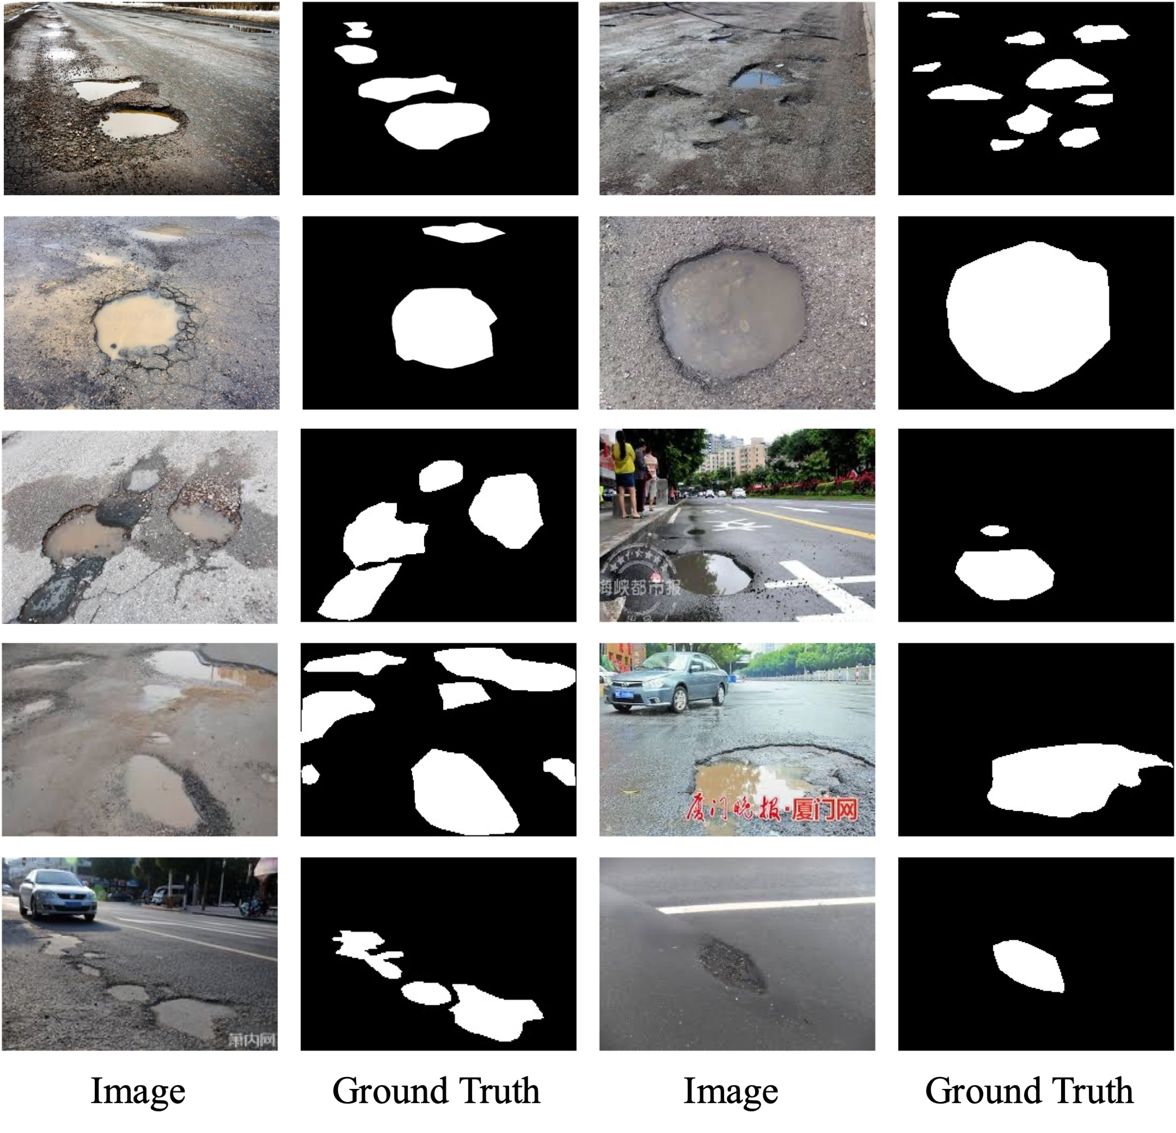

Figure 2. Some representative samples in the proposed dataset. These images are collected from the internet and some of the photos are took by ourselves.

Figure 3 shows the distribution of number of potholes in all images.

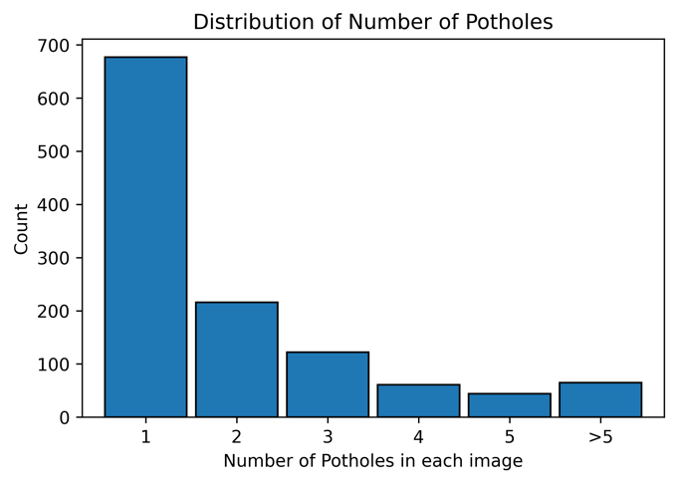

Figure 3. the distribution of number of potholes in each image.

The images collected from google can be useful for the generalization of the dataset, because it contains various noise including people, buildings, shades. Below are some statistical results from the self-collected dataset.

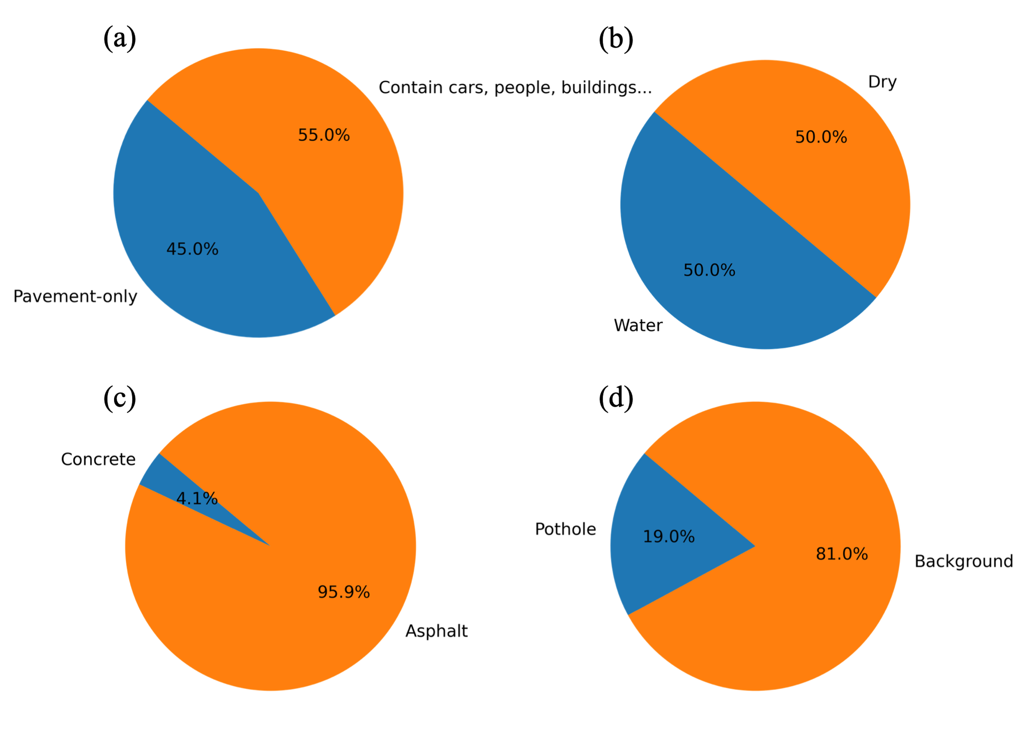

Figure 3. The statistics in the dataset. (a) the

Because the images are collected from different sources, therefore, they have different resolutions. Thus, before input into the deep learning model, all the images would be resized to $256×256$ pixels automatically before the model training procedure.

The images and the annotated ground truth in the training set were both applied data augmentation methods including random resize and random horizontal flipping during training for all the experiments. The augmented images will be totally new inputs to the neural network.

By doing this, the deep learning-based model’s performance would be improved because deep learning algorithm is deep related on the amount and diversity of datasets it used.

After augmentation, the training set is processed by changing the color to gray.

Add some distribution of the data.

Give some annotation samples.

Table 1 presents a comparative analysis of various models, including the proposed PoFormer model, based on their performance metrics.

Table 1. mIoU and mPA of all the models

|  |  |  |  |  |  |  |
| --- | --- | --- | --- | --- | --- | --- |
| Model | FPS | #Parameters | mIoU | | mPA | |
|  |  |  | Ave | std | Ave | Std |
| FCN | 25.37 | 32940481 | 69.44 | 0.63 | 78.23 | 0.83 |
| ENet | 24.34 | 355538 | 73.81 | 1.28 | 81.66 | 1.51 |
| LRASPP | 30.90 | 3217850 | 77.19 | 0.31 | 84.24 | 0.22 |
| Unet | 30.51 | 13394177 | 71.3 | 1.63 | 78.61 | 1.31 |
| AttuNet | 23.54 | 34877421 | 75.48 | 0.49 | 82.73 | 0.52 |
| PoFormer | 20.47 | 45921665 | 77.23 | 0.84 | 84.48 | 1.14 |

The models are evaluated on frames per second (FPS), number of parameters, mean Intersection over Union (mIoU), and mean Pixel Accuracy (mPA), with the latter two having both average (Ave) and standard deviation (std) values reported.

The FPS column indicates the speed of the model's inference, with higher numbers signifying faster performance. The '#Parameters' column lists the complexity of each model in terms of the total number of parameters, with lower numbers indicating a more lightweight model.

The mIoU is a common metric for the accuracy of segmentation tasks, representing the average ratio between the intersection and the union of the predicted and ground truth pixels across all classes. The mPA reflects the pixel-wise accuracy over the entire dataset.

FCN: Fully Convolutional Network achieves an average mIoU of 69.44 with a standard deviation of 0.63, and an average mPA of 78.23 with a standard deviation of 0.83, operating at 25.37 FPS and with over 32 million parameters.

ENet: Designed for efficiency, ENet boasts a smaller model size at 355,538 parameters. It operates at 24.34 FPS and outperforms FCN with a higher average mIoU of 73.81 and a mean mPA of 81.66, though it has greater variability as reflected by higher standard deviations.

LRASPP: This model achieves the best performance among the compared models with an mIoU of 77.19 and an mPA of 84.24, showing the least variance in its predictions. It also has the highest FPS rate at 30.90, indicating faster inference, and it maintains a moderate size with around 3.2 million parameters.

Unet: With a relatively higher model complexity of over 13 million parameters, Unet records an average mIoU of 71.3 and an mPA of 78.61, both with standard deviations above 1, indicating moderate variability. Its FPS is competitive at 30.51.

AttuNet: This model has a considerable number of parameters, similar to FCN, and operates at 23.54 FPS. It achieves an mIoU of 75.48 and an mPA of 82.73, with low standard deviations indicating consistent performance across runs.

PoFormer: The proposed model in the paper, PoFormer, while not the fastest at 20.47 FPS, exhibits a high level of accuracy with an mIoU of 77.23 and an mPA of 84.48, the latter being the highest among all models. The standard deviations suggest a moderate level of variance. However, it is the most complex model with over 45 million parameters.

The table indicates that while PoFormer has a higher computational complexity, it competes closely with LRASPP in terms of mIoU and surpasses all other models in mPA, suggesting that the trade-off in model size and speed may be justified by its accuracy in segmentation tasks.

Some visualization of detection results of these deep learning-based models is shown in Figure 4 to show their segmentation performance.

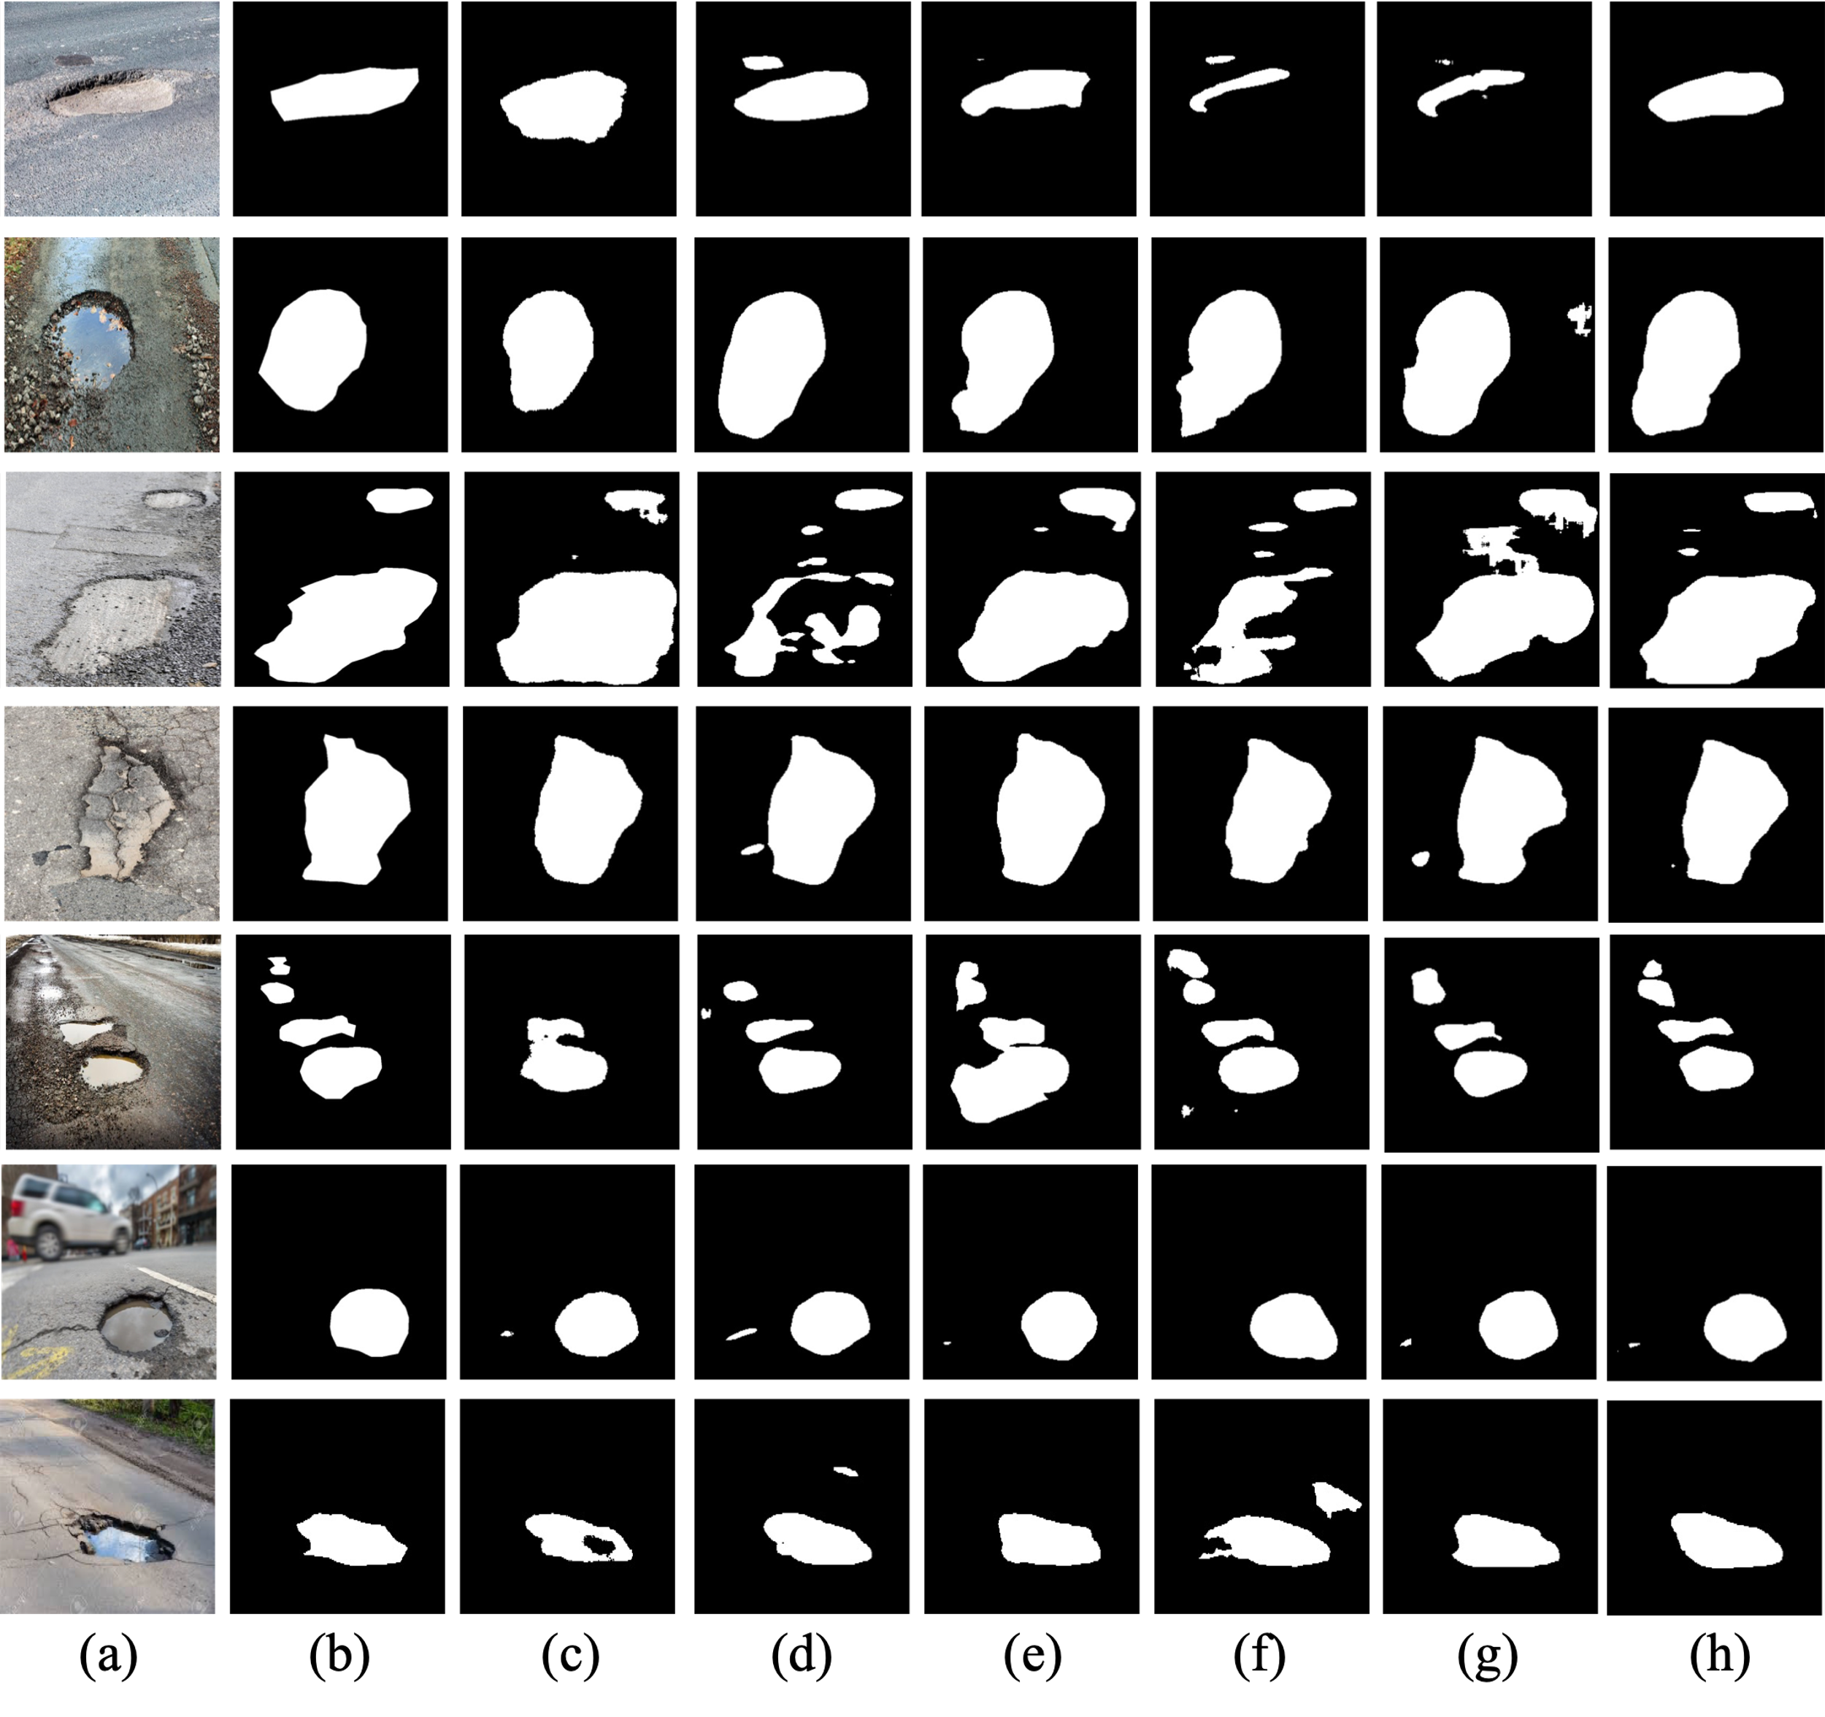

**Figure 4.** The visualization of detection results of compared methods: (a) Original Image; (b) Ground Truth; (c) Enet; (d) FCN; (e) LRASPP; (f) Unet; (g) AttuNet; (h) PoFormer.

As we can see from Figure 4., the results from FCN, DeepLabV3 and LRASPP are intermittent compared to the ground truth especially in the red-circle part. The segmented images of DeepCrack and ECSNet are quite consistent with the ground truth compared to other models. It shows that the segmentation results from DeepCrack are the closest to the ground truth.

Figure 4 provides a visual comparison of the segmentation performance of various deep learning-based models. Column (a) presents the Original Images, showcasing the raw photographs of pavement surfaces that include potholes and other features. These images serve as the input to the segmentation models. Column (b) displays the Ground Truth, which are binary masks manually annotated to indicate the precise locations and shapes of the potholes. The white areas represent the potholes, and the black background represents the non-pothole areas of the pavement. Columns (c) through (h) illustrate the segmentation results of the models under comparison: Enet, FCN, LRASPP, Unet, AttuNet, and PoFormer, respectively. In these columns, the white areas denote the potholes as identified by each respective model, and the black areas denote the background.

The figure effectively demonstrates how each model interprets the input images and how closely its segmentation aligns with the Ground Truth. The accuracy of the models can be inferred by the similarity between the Ground Truth masks and the predicted masks by the models. For example, a model with a predicted mask that closely resembles the Ground Truth mask would be considered more accurate in its pothole detection capabilities.

In the visualization, PoFormer is of particular interest as it represents the novel model proposed in the paper. The results for PoFormer can be compared against the other models to highlight its segmentation efficacy. Discrepancies such as over-segmentation (predicting non-pothole areas as potholes) or under-segmentation (missing parts of the pothole) can be qualitatively assessed across different models. The figure serves as a clear visual representation to support the quantitative data presented in Table 1, giving a more comprehensive understanding of each model's performance.

# 4. Conclusion

The research presented in this paper successfully proposes and validates PoFormer, a CNN-Transformer hybrid model, as an effective tool for segmentizing pavement potholes. The model's encoder-decoder structure leverages the strengths of both architectures, offering improved accuracy in the segmentation of potholes compared to traditional deep learning models. Our experimental results confirm that PoFormer achieves superior performance metrics, with a mIoU of 77.23% and a mPA of 84.48%. These results substantiate the model's capability to accurately segment potholes, which is essential for the development of intelligent transportation systems and infrastructure maintenance. Future research directions include optimizing the model's computational efficiency and extending its application to other pavement distress types such as cracks and various defects. The findings of this study provide a foundation for the advancement of automated pavement condition assessment techniques, with the potential to significantly impact the field of transportation infrastructure management. The contributions of this research extend beyond pothole segmentation. The integration of transformers into pavement analysis tasks opens up new avenues for advanced computer vision techniques in transportation infrastructure management.

References

[1] T. Kim and S.-K. Ryu, "Review and analysis of pothole detection methods," *Journal of Emerging Trends in Computing and Information Sciences,* vol. 5, no. 8, pp. 603-608, 2014.

[2] A. Dhiman and R. Klette, "Pothole detection using computer vision and learning," *IEEE Transactions on Intelligent Transportation Systems,* vol. 21, no. 8, pp. 3536-3550, 2019.

[3] R. Fan, H. Wang, M. J. Bocus, and M. Liu, "We learn better road pothole detection: from attention aggregation to adversarial domain adaptation," in *Computer Vision–ECCV 2020 Workshops: Glasgow, UK, August 23–28, 2020, Proceedings, Part IV 16*, 2020: Springer, pp. 285-300.

[4] S. Mathavan, K. Kamal, and M. Rahman, "A review of three-dimensional imaging technologies for pavement distress detection and measurements," *IEEE Transactions on Intelligent Transportation Systems,* vol. 16, no. 5, pp. 2353-2362, 2015.

[5] E. Buza, S. Omanovic, and A. Huseinovic, "Pothole detection with image processing and spectral clustering," in *Proceedings of the 2nd International Conference on Information Technology and Computer Networks*, 2013, vol. 810, p. 4853.

[6] C. Koch and I. Brilakis, "Pothole detection in asphalt pavement images," *Advanced engineering informatics,* vol. 25, no. 3, pp. 507-515, 2011.

[7] T. Zhang, D. Wang, and Y. Lu, "ECSNet: An Accelerated Real-Time Image Segmentation CNN Architecture for Pavement Crack Detection," *IEEE Transactions on Intelligent Transportation Systems,* 2023.

[8] E. N. Ukhwah, E. M. Yuniarno, and Y. K. Suprapto, "Asphalt pavement pothole detection using deep learning method based on YOLO neural network," in *2019 International Seminar on Intelligent Technology and Its Applications (ISITIA)*, 2019: IEEE, pp. 35-40.

[9] K. R. Ahmed, "Smart pothole detection using deep learning based on dilated convolution," *Sensors,* vol. 21, no. 24, p. 8406, 2021.

[10] A. Vaswani *et al.*, "Attention is all you need," *Advances in neural information processing systems,* vol. 30, 2017.

[11] A. Dosovitskiy *et al.*, "An image is worth 16x16 words: Transformers for image recognition at scale," *arXiv preprint arXiv:2010.11929,* 2020.

[12] S. Zheng *et al.*, "Rethinking semantic segmentation from a sequence-to-sequence perspective with transformers," in *Proceedings of the IEEE/CVF conference on computer vision and pattern recognition*, 2021, pp. 6881-6890.

[13] F. Guo, Y. Qian, J. Liu, and H. Yu, "Pavement crack detection based on transformer network," *Automation in Construction,* vol. 145, p. 104646, 2023.

[14] C. Han *et al.*, "Asphalt Pavement Health Prediction Based on Improved Transformer Network," *IEEE Transactions on Intelligent Transportation Systems,* vol. 24, no. 4, pp. 4482-4493, 2022.

[15] J. Xu, W. Shi, P. Gao, Z. Wang, and Q. Li, "UperFormer: A Multi-scale Transformer-based Decoder for Semantic Segmentation," *arXiv preprint arXiv:2211.13928,* 2022.

[16] S. Ioffe and C. Szegedy, "Batch normalization: Accelerating deep network training by reducing internal covariate shift," in *International conference on machine learning*, 2015: pmlr, pp. 448-456.

[17] K. He, X. Zhang, S. Ren, and J. Sun, "Deep residual learning for image recognition," in *Proceedings of the IEEE conference on computer vision and pattern recognition*, 2016, pp. 770-778.

[18] T. Kurbiel and S. Khaleghian, "Training of deep neural networks based on distance measures using RMSProp," *arXiv preprint arXiv:1708.01911,* 2017.

[19] E. Salcedo, M. Jaber, and J. R. Carrión, "A Novel Road Maintenance Prioritisation System Based on Computer Vision and Crowdsourced Reporting," *Journal of Sensor and Actuator Networks,* vol. 11, no. 1, p. 15, 2022.

[20] T. Zhang, D. Wang, A. Mullins, and Y. Lu, "Integrated APC-GAN and AttuNet Framework for Automated Pavement Crack Pixel-Level Segmentation: A New Solution to Small Training Datasets," *IEEE Transactions on Intelligent Transportation Systems,* 2023.